|  |  |
| --- | --- |
|  | **2012** |
|  |  |

|  |
| --- |
| [Team Napa] |
|  |

Table of Contents

Designing of Car….............................................................................................Page 2

Creating Chassis…………………………………………………………………….Page 2-5

Brakes and Steering…………………………………………………………………Page 6

Suspension and Rear Chassis……………………………………………………..Page 7-8

Electronics and Firewall……………………………………………………………..Page 8-9

Finished Product and Thanks to sponsors…………............................................Page 10



Team NAPA

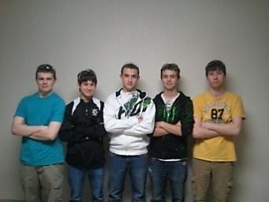

*From left to right: Carson Cozzens, Matt Pasterski, Nick Stueber, Nick Treadway, Joe Van Egeren*

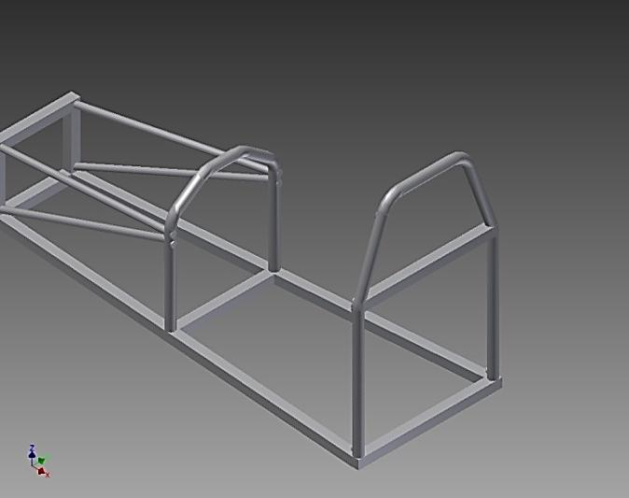

On our first few weeks of progress we successfully welded together the base chassis as shown to the left. We also took some time to practice welding on some scrap metal just so we would be ready to weld the rest correctly.

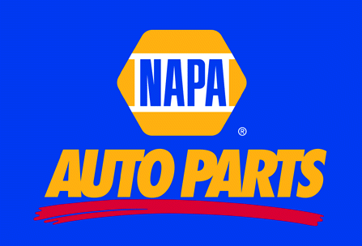

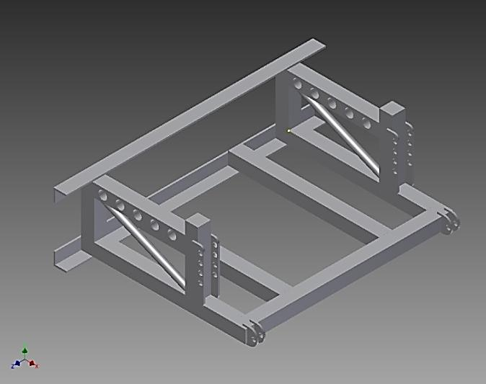

Our team designed the rear chassis as shown to the left. It was not yet built at this time but we came up with a good idea for a suspension system that would allow for a smoother and more efficient ride.

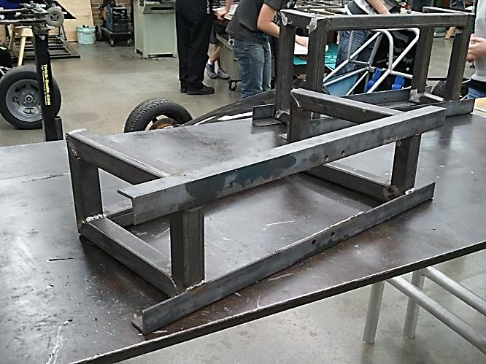

This is the start of the assembly of the rear chassis. We had to make sure it was completely square and level in order for this to work correctly.

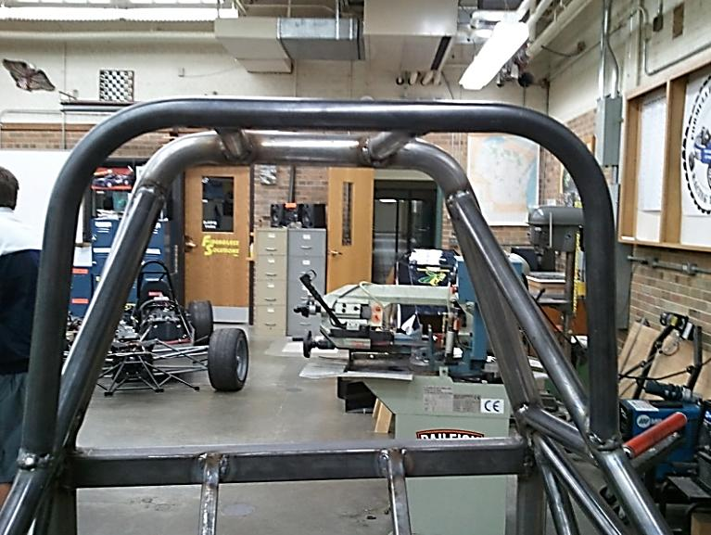

Later on, we started the assembly of the base chassis. We successfully bent the halo bar and welded it into place as seen in the picture to the left. After that we cut and welded in place the seat support bars to support the aluminum firewall.



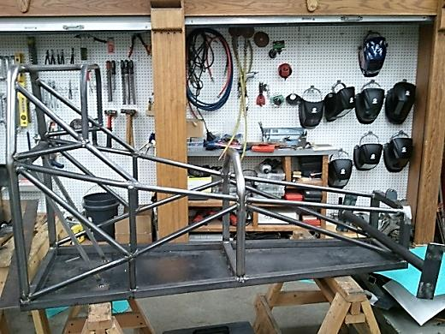

This is the completed base chassis along with the front axle. The axle at this point was not ready to be welded onto the chassis because we still needed to make a few slight adjustments to it first. Also we started to cut out the kill switch mounting plates and start welding them on.

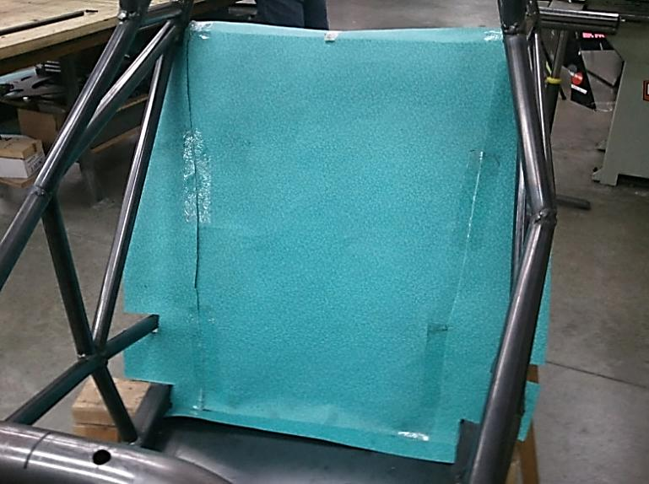

We then started to cut out the template for the aluminum firewall which would be needed in the future to make it easier to cut the aluminum to the perfect size. During this time we also cut the holes in the middle roll bar in order to bolt down the steering wheel.

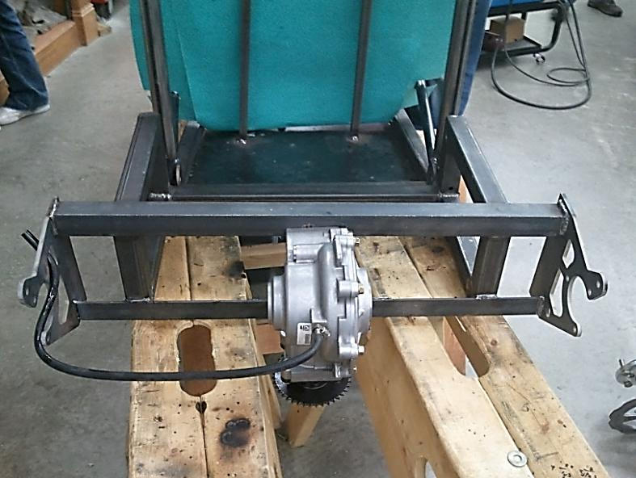

At this point we also finished the differential that was bolted onto the rear chassis and also the brackets on each side that would hold the rear axle in its place. At this point everything in the back had to be perfectly level so that the axle would not wobble at all.



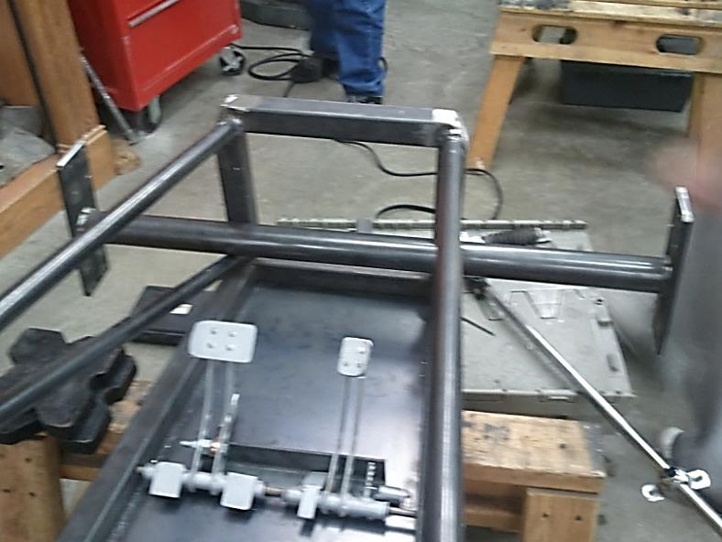

In the picture shown to the left you can see the pedals that were attached to the chassis. We made sure that everyone on the team could reach the pedals and still be comfortable on the seat at the same time. This picture also shows the front that had to be grinded down in order to fit the nose cone over the chassis.

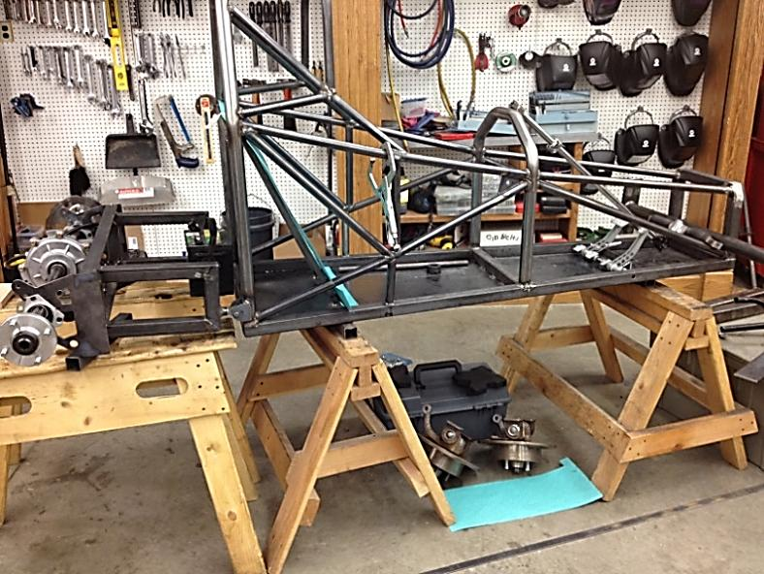

This is a picture of the full chassis put together along with the rear axle put into place just to see if it would work correctly. We also welded and drilled the brackets that would attach the rear chassis and allow for suspension.

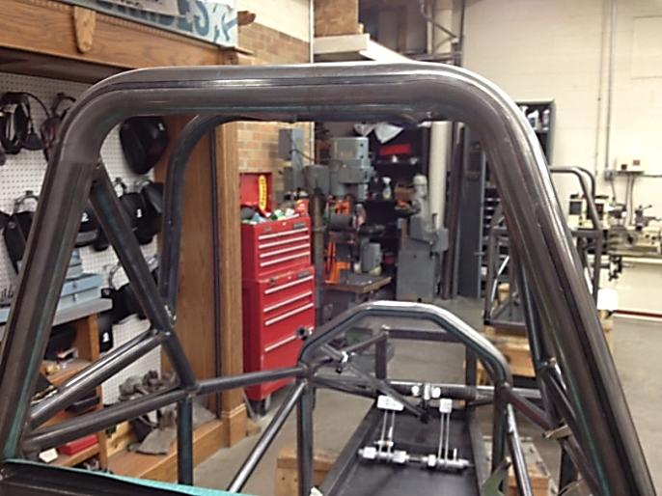

In this picture you can see the steering rod coming up from the front of the chassis. At this point we started finding a way to bolt it to the middle roll bar.

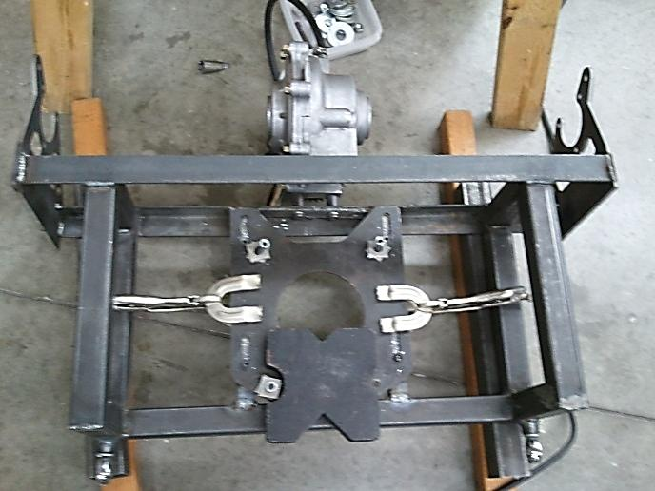

We then took off the rear axle on the rear chassis and started to take the engine plate off the engine. We cut two support bars that are welded underneath the plate. And we drilled holes through them in order to mount the engine.

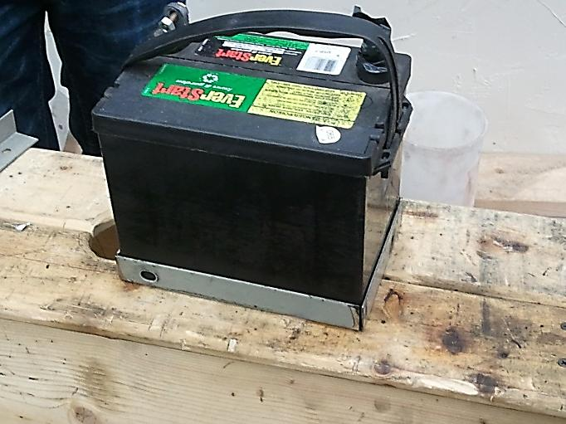

We had to design an efficient way to hold up the battery and mount it to the front of the car. So we simply just cut 4 pieces at 45 degree angles and welded them together as shown in the picture at the left. This worked very well and looks pretty nice too.

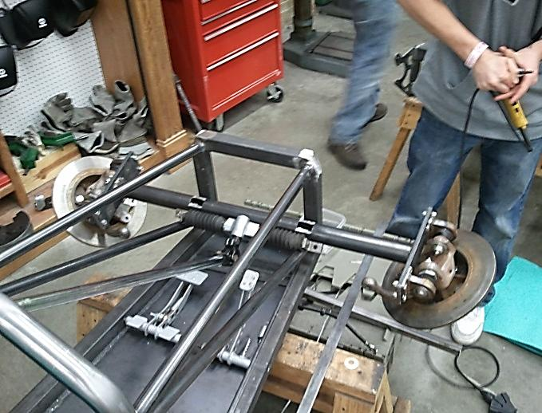

This is the front axle that is basically ready to be welded onto the car. We have mounting plates that were cut out on the plasma cutter and all we have to do is just weld it on. But before we do that we have to finish bolting on the disk brakes.

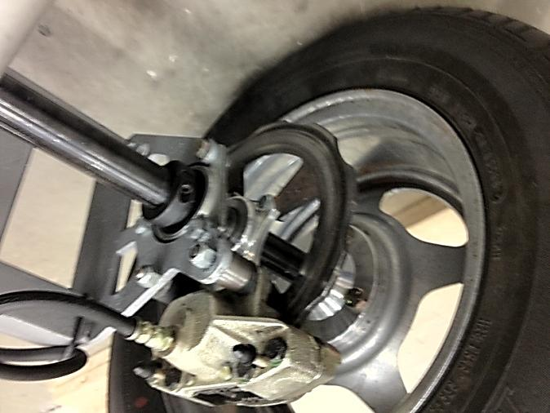

At this point we got all of the brake calipers put onto our front and rear wheels. The wheels were also mounted on both the front and rear axles.

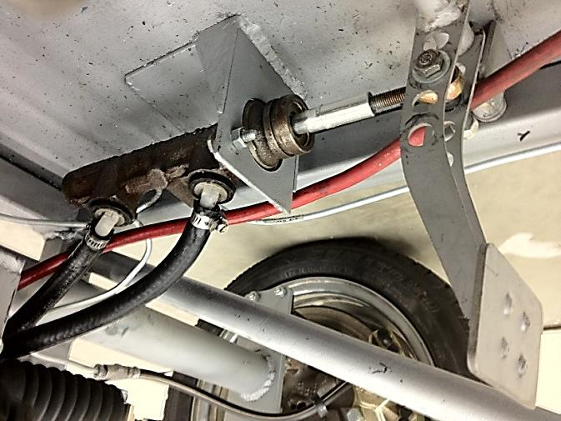

We mounted the brake pedal correctly and welded a plate onto the car to hold parts of the brake onto the car. The brakes were bled to make sure that when the brake pedal was pushed down it would be sensitive enough and be able to stop the car in time.



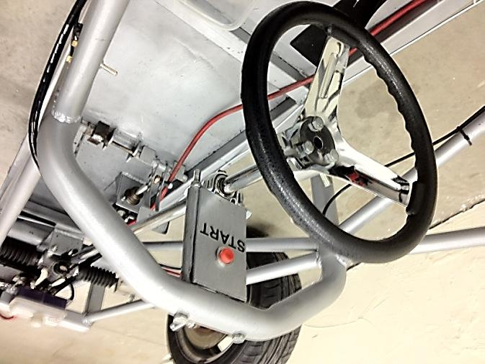

In the picture to the left you can see that we have our steering assembly mounted to our car. The start button which is in red is also mounted; this is used to start the car by pushing in the red button.

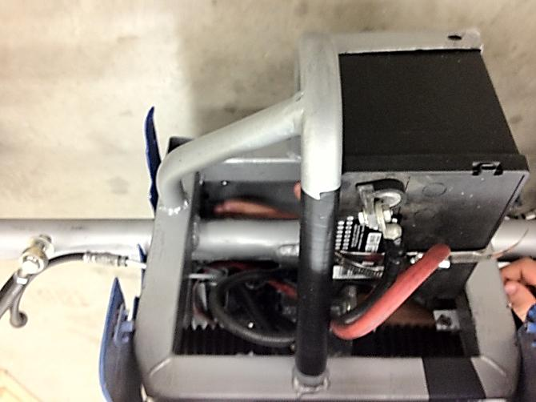

This shows our battery that was mounted to the front of our car. We put it sideways on purpose so that it would fit inside the nosecone of the car. We used 2 large hose clamps and put them together, then wrapped them around the side of the battery to hold it down.

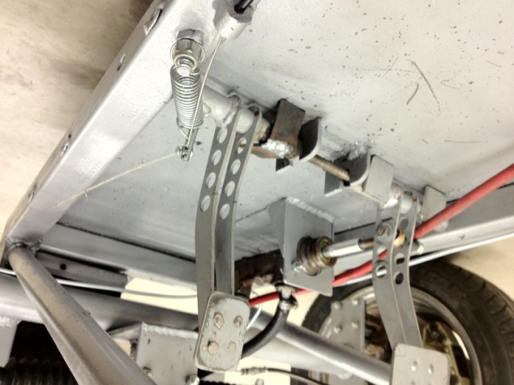

The gas pedal was also mounted onto the car shortly after the brake. We welded two metal stoppers to keep from pushing too far down on the throttle. The throttle cable runs up the right side of the car and is put through a metal cylinder to hold the throttle casing from sliding when pushing on the gas.

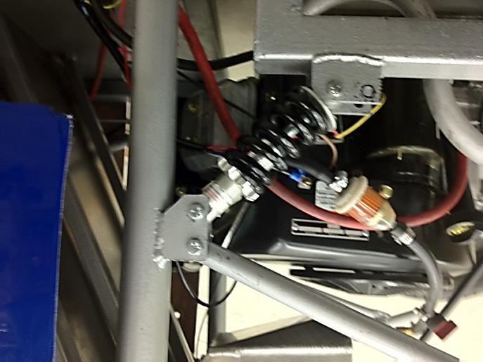

This picture shows our mounted engine and also the rear suspension that we had developed for our car. This allowed our car to stay on the ground as much as possible and maintain its speed and allow for a less bumpy ride.



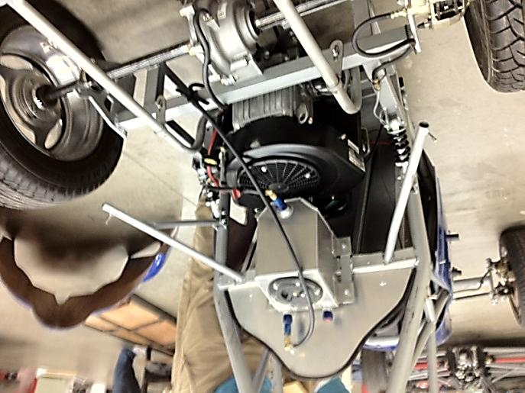

Our fuel cell was mounted to the rear of our car right above the engine. The rear fiberglass body was also supported by two metal rods that came out from each side of the chassis. The exhaust system is also shown near the bottom of the picture.

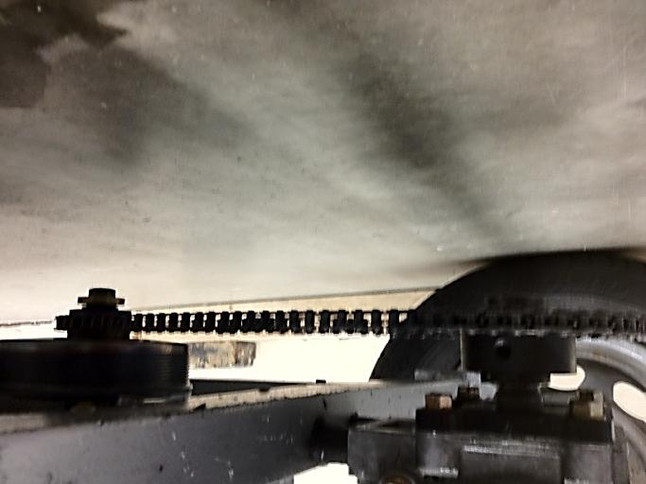

This picture shows underneath our car. You can see the differential attached to the engine by a chain. It took us a while to break and put together the chain to make it the correct length to reach the differential and still be somewhat tight.

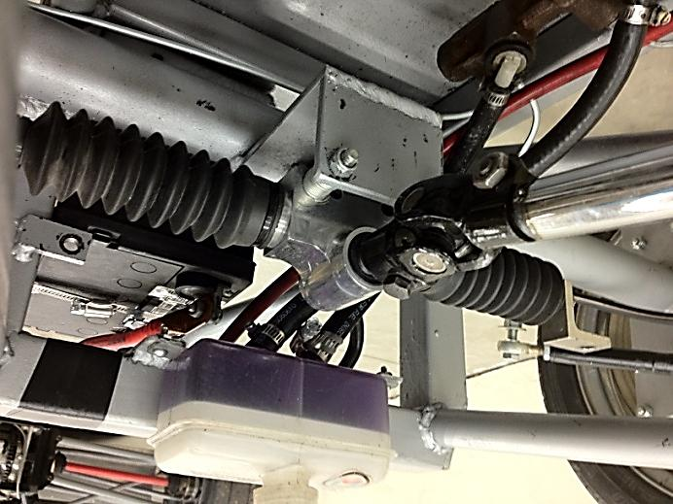

The steering rod was assembled by being bolted to a plate that was welded onto our front axle. Mounted right above the steering rod was a container that held the brake fluid and it was also bolted down to two tabs.



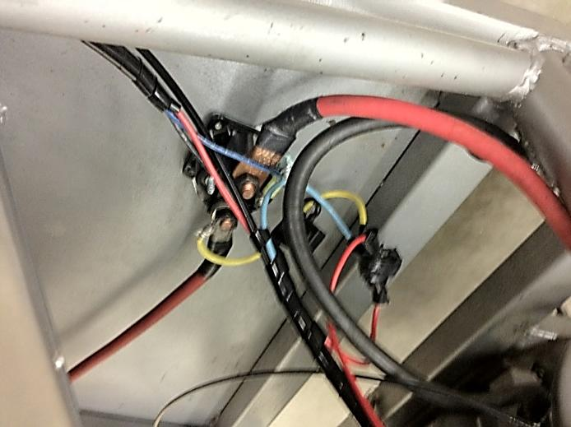

This shows a picture of our starter solenoid. It was simply bolted down behind the firewall. We used an electric diagram to help with the layout of it and used zip ties to keep the cords held down close to the metal chassis to make sure they didn’t touch the exhaust and melt.

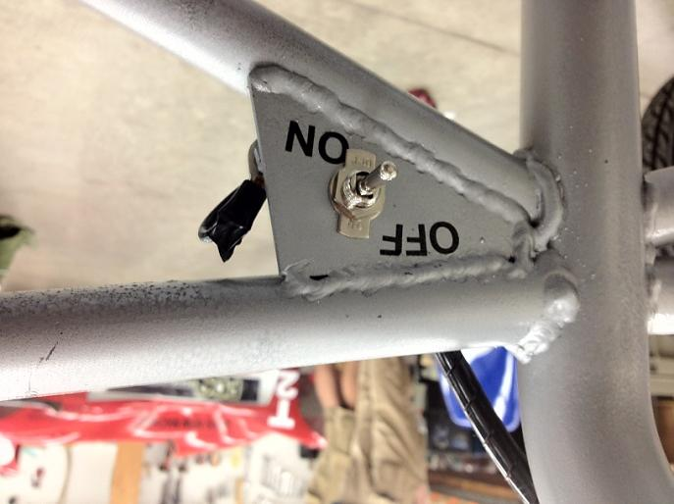

A triangle plate was mounted and welded between two bars on our chassis. We drilled a hold and put a toggle switch to serve as a kill switch for the engine. After that was mounted we had to label which side was on and off and to make sure that it was very clear to see.

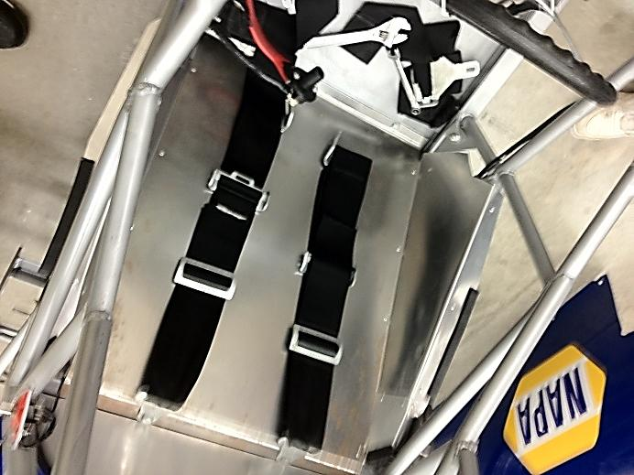

The rules for the formula car require that a 5 point harness be used to secure the driver in the car, so we bolted down each part of the harness onto the chassis of the car in order to follow that rule. In the picture you can also see the side flaps on the firewall that were needed in order to extend out to the side of the fiberglass body.

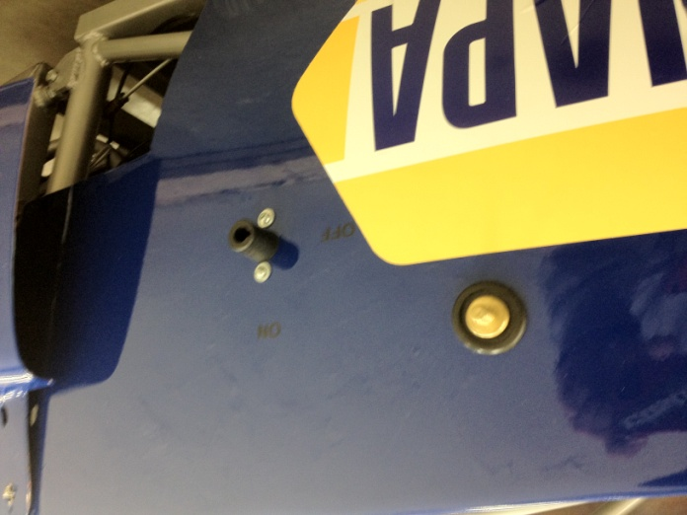`

On the side of our car we mounted a special jumper system to the fiberglass. In case we need to jump start our car we simply just run a cable to the battery and start the car up and it should work. Also mounted on the side of the car is the hole for the key that gets put in for it to start.

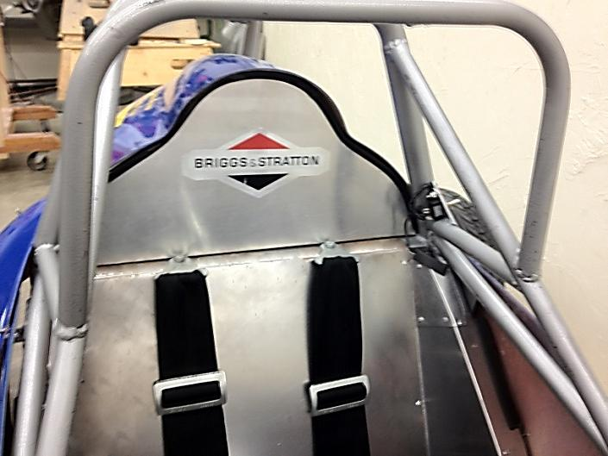

This picture shows the firewall that was put above the seat in order to reach all the way to the fiberglass. It was trimmed with some rubber to make sure that it was a tight fit and looked smoother along the edges. We also put a logo on the firewall for Briggs & Stratton.

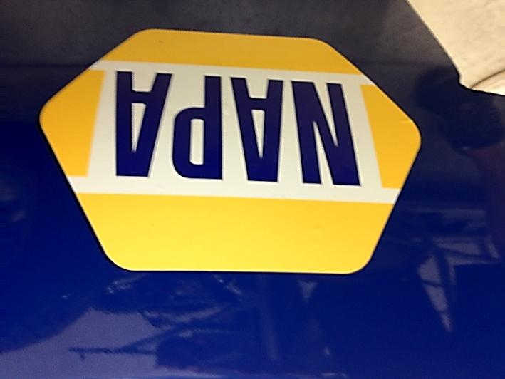

Lastly before we left to put our cars into the trailer for track day we put on the NAPA logo to each side of our car. We used a special solution to help keep bubbles out of the sticker when it was put on the car.

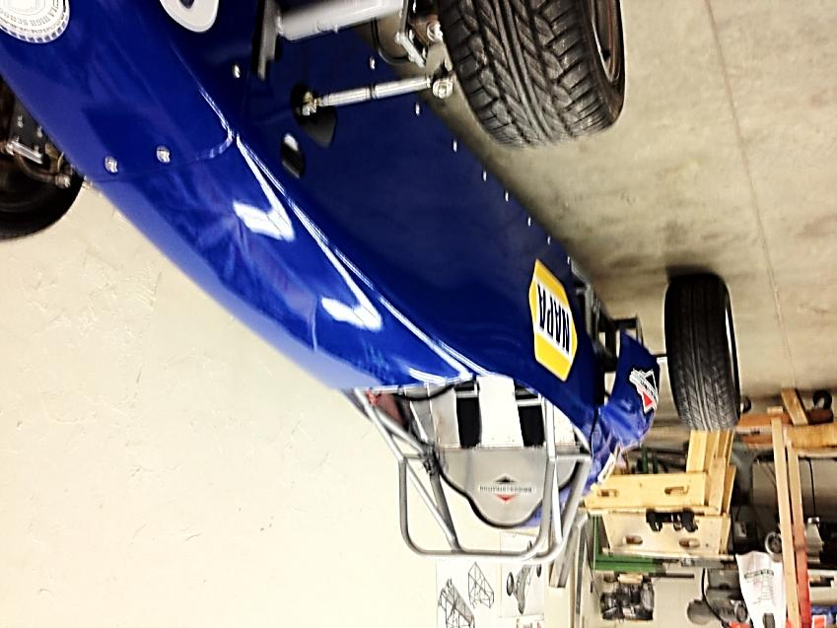

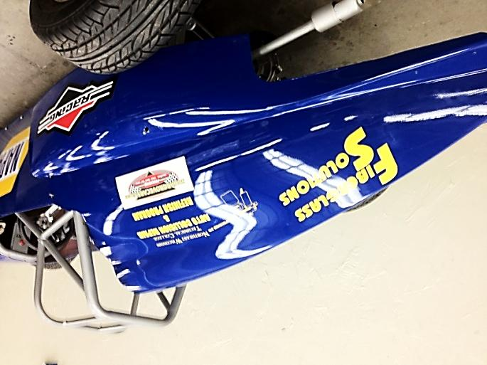



Thanks to All of Our Sponsors!

